Kronecker product

Def

Given $$A$$ with $$m$$ rows $$n$$ columns

and $$B$$ with $$p$$ rows $$q$$ columns (of course $$m,n,p,q$$ are both real positive integers).

Kronecker product of $$A$$ and $$B$$ will be a block matrix $$C$$ with $$p⋅m$$ rows $$q⋅n$$ columns.

$$c_{r,w}$$ = $$a_{r\%m,w\%n}b_{r\%p,w\%q}$$ for all $$r,w$$ is an integer , $$1≤r≤p⋅m$$ and $$1≤w≤n⋅q$$

Here % refers modulus. $$a\%b=mod\left(a,b\right)$$

Property



Distributivity



Associativity



Scalability



Zero matrix



Assocativity with matrix that are mixed product



Associativity with Hadmard product of matrices



Inverse matrix



Moore-Penrose psuedoinverse matrix



Transpose matrix



Conjugation transpose matrix



Determinant of two square matrices

Generalized form (any matrix)



Square matrix

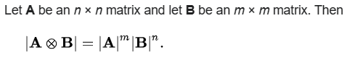

Kronecker sum with two matrices whose product of identity matrix



NOTICE

NOTICE that Kronecker product does NOT have communicativity. That is,



is NOT always equal to



However, it has permutation communicativity. That is, there exist permuation matrices $$P$$ and $$Q$$ such that



Eigenvalue

Generalized form



Symmetric and square matrix





Proof of property

Let’s started with zero matrix property first.

The following assumptions are applied in all proof.

Suppose:

matrix $$A$$ with $$m$$ r ows $$n$$ columns and

matrix $$B$$ with $$p$$ rows $$q$$ columns.

matrix $$C$$ with $$o$$ rows $$u$$ columns.

matrix $$D$$ with $$y$$ rows $$t$$ columns.

Additionally, for convenience to write formula

I use subscription of a matrix $$A$$ to represent the elem given index (I.e. row and column) of $$A$$ and subscription with the corresponding lowecase to represent it.

For example

$$a_{1,2}$$ refers the elem in 1th row 2th column of matrix $$A$$.

Does $$A_{1,2}$$ so.

On top of that, for convience, we use these symbol $$r,r_{0},r_{1},…$$

to represent any positive integer that within the size of matrix.

Does $$w,w_{0},w_{1},…$$ so.

Zero matrix

Axiom , since all elements is $$0$$ in zero matrix.

Scalability

$$A$$ = $$\left[a_{r,w}\right]$$ for $$r,w$$ are in size of $$A$$

$$B$$ = $$\left[b_{r,w}\right]$$ for $$r,w$$ are in size of $$B$$

We have that

$$kA$$

= $$\left[k⋅a_{r,w}\right]$$

$$kB$$

= $$\left[k⋅b_{r,w}\right]$$

First, we have that



= $$\left[k⋅a_{r⋅i,w⋅j}⋅b_{\left(r−1\right)⋅p+1,\left(w−1\right)⋅a+j}\right]$$

Next



= $$\left[a_{r⋅i,w⋅j}⋅\left(k⋅b_{\left(r−1\right)⋅p+1,\left(w−1\right)⋅q+j}\right)\right]$$

Because of communicativity of multiplication for two complex numbers,



Associativity

First, we have that



= $$\left[a_{r,w}⋅b_{\left(r−1\right)⋅p+r_{2},\left(w−1\right)⋅q+w_{2}}\right]$$

Next,



= $$\left[b_{r,w}⋅c_{\left(r−1\right)⋅o+r_{0},\left(w−1\right)⋅u+w_{0}}\right]$$

On the other hand,



= $$\left[a_{r⋅r_{3},w⋅w_{3}}⋅b_{\left(\left(r−1\right)⋅p+r_{2}\right)⋅r_{3},\left(\left(w−1\right)⋅q+w_{2}\right)⋅w_{3}}⋅c_{\left(n⋅p−1\right)⋅o+r_{3},\left(m⋅q−1\right)⋅u+w_{3}}\right]$$



= $$\left[a_{r⋅r_{4},w⋅w_{4}}⋅b_{\left(r−1\right)⋅p⋅o+r_{4},\left(w−1\right)⋅q⋅u+r_{4},}⋅c_{\left(\left(r−1\right)⋅o+r_{0}−1\right)⋅p⋅o+r_{4},\left(\left(w−1\right)⋅u+w_{0}−1\right)⋅q⋅u+r_{4}}\right]$$

Thus, after one combines two above equations and simplifies the equations (especially the index), one will get



Distributivity

We will only prove



For others, such as



Doing similar things.

First,

$$B+C$$

= $$\left[b_{r,w}+c_{r,w}\right]$$

for all $$1≤r≤p$$, $$1≤w≤q$$

Then

= $$\left[a_{r⋅i,w⋅j}⋅{\left(B+C\right)}_{\left(r−1\right)⋅p+i,\left(w−1\right)⋅q+j}\right]$$

for all $$1≤i≤n⋅p$$, $$1≤j≤m⋅q$$

For range of $$r,w$$, it refers above range (it was put in $$B+C$$ statement).



= $$\left[a_{r⋅i,w⋅j}⋅b_{\left(r−1\right)⋅p+i,\left(w−1\right)⋅q+j}\right]$$

See above range.



= $$\left[a_{r⋅i,w⋅j}⋅c_{\left(r−1\right)⋅p+i,\left(w−1\right)⋅q+j}\right]$$

Thus,



= $$\left[a_{r⋅i,w⋅j}⋅b_{\left(r−1\right)⋅p+1,\left(w−1\right)⋅a+j}\right]$$

+ $$\left[a_{r⋅i,w⋅j}⋅c_{\left(r−1\right)⋅p+1,\left(w−1\right)⋅a+j}\right]$$

= $$\left[a_{r⋅i,w⋅j}⋅{\left(B+C\right)}_{\left(r−1\right)⋅p+1,\left(w−1\right)⋅a+j}\right]$$

which completes proof.

Associativity with matrix that are mixed product



First,



= $$\left[a_{r,w}⋅b_{\left(r−1\right)⋅p+r_{2},\left(w−1\right)⋅q+w_{2}}\right]$$



= $$\left[c_{r,w}⋅d_{\left(r−1\right)⋅p+r_{3},\left(w−1\right)⋅q+w_{3}}\right]$$

By definition of inner product of matrix, we have that

E

=

= $$\left[e_{r,w}\right]$$

where

$$e_{r,w}=sigma\left(a_{r,k}⋅c_{k,w},k=1,k=n\right)$$

F

=

= $$\left[f_{r,w}\right]$$

where

$$f_{r,w}=sigma\left(b_{r,k}⋅d_{k,w},k=1,k=n\right)$$

On the other hand,

=

= $$\left[g_{r,w}\right]$$

where

$$g_{r,w}=sigma\left(e_{r,k}⋅f_{k,w},k=0,k=n\right)$$

While

=

= $$\left[e_{r⋅r_{4},w⋅w_{4}}⋅f_{\left(r−1\right)⋅p+r_{4},\left(w−1\right)⋅t+w_{4}}\right]$$



Transpose matrix



First, we have that



= $$\left[a_{r,w}⋅B\right]$$



= $${\left[a_{r,w}⋅B\right]}^{T}$$

= $$\left[a_{w,r} ⋅B^{T}\right]$$

$$A^{T}$$

= $$\left[a_{w,r} \right]$$

$$B^{T}$$

= $$\left[b_{w,r}\right]$$



= $$\left[a_{w,r}⋅b_{\left(w−1\right)⋅q+w_{2},\left(r−1\right)⋅p+r_{2}}\right]$$

Thus,



For property about conjugate transpose,



We will skip the detailed proof, since the conjugate matrix is matrix whose all elem is conjugated.

Determinant of two square matrices

First, consider the size of two square matrices.

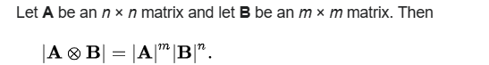

Since $$A$$ with $$n$$ rows $$n$$ columns and $$B$$ with $$m$$ rows $$m$$ columns,

E =  has $$n⋅m$$ rows $$n⋅m$$ columns.

Second, divide it into many parts with determinant property. The formula is called Leibniz

formula.

Recall:

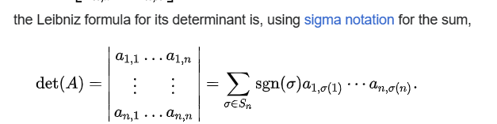

Furthermore, the determinant of a matrix is the determinant of its blocking matrices

For example,

$$\det\left(A\right)$$

= $$\det\left(\left[A_{1;1}A_{1;2} A_{2;1} A_{2;2}\right]\right)$$

= $$\det\left(A_{1;1}\right)$$ $$\det\left(A_{1;2}\right)$$* - $$\det\left(A_{2;1}\right)$$ $$\det\left(A_{2;2}\right)$$

*

Recall:

Recall the definition of Kronecker product.

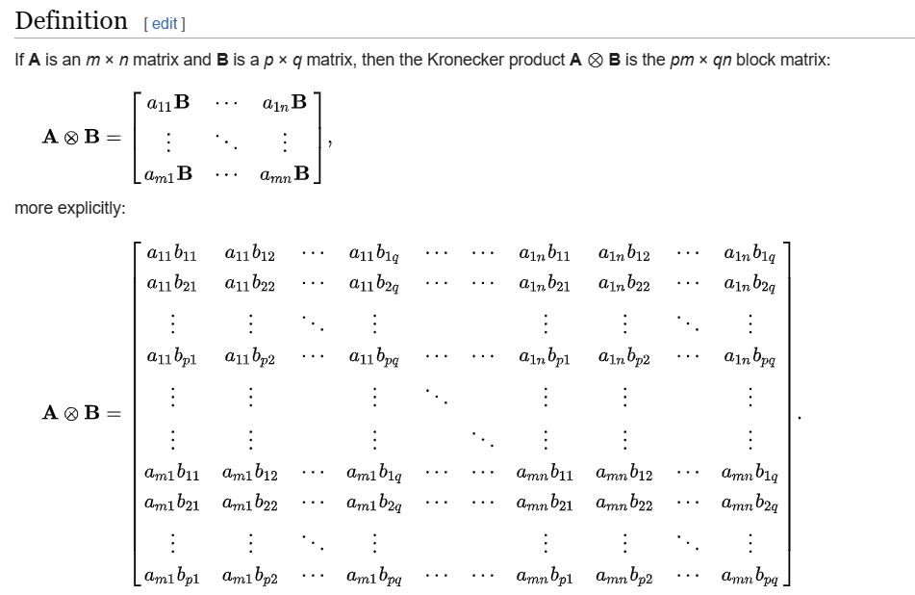

For convenience, we first define these symbols.

1. $$A_{\left\{R,W\right\}}$$ is defined as all elems of A whose row is NOT in $$R$$ and column is NOT in $$W$$ (before performing this operation, check if $$R$$ is a set. If it is NOT a set, it will be converted to set $$\left\{R\right\}$$, and so fot $$W$$)
2. $$@$$ is defined as concatenation of two sets. Since uniqueness of set , they are equivalent. $$union\left(R,i\right)$$ and $$R@i$$.Here, in $$R@i$$ If elem $$i$$ is in $$R$$, $$R@i$$ will be $$R$$. $$R@i$$ will also return a set. (Before performing this operation, check if $$R$$ is a set, if it is NOT a set, $$R$$ will be converted to set $$\left\{R\right\}$$)
3. Partially summation:

I defined $$sigma\left(f\left(i\right),i=k,i=n,i=p\right)$$ as apply $$f\left(i\right)$$ with parameter started

point at $$k$$, interval $$p$$ repeated until $$i>n$$.

That is,

$$sigma\left(f\left(i\right),i=k,i=n,i=p\right)$$ = $$f\left(k\right)+…+f\left(k+floor\left(\frac{\left(n−m\right)}{p}\right)⋅p\right)$$

Additionally, for convenience, we redefined the determinant of $$A$$ with size $$3⋅3$$, size $$2⋅2$$, and size $$1⋅1$$ (extend the concept of Leibinz formula). But don’t worry about it. One can prove that the determinant of $$A$$ after redefined is equivalent to the determinant of $$A$$ before redefined. We will prove it later.

For matrix $$A$$ with size $$3⋅3$$ and size $$2⋅2$$,

It is redefined as something similar to Leibniz formula.

More explicitly to say,

$$\det\left(A\right)$$ = $$sigma\left({\left(−1\right)}^{i}⋅a_{1,i}⋅\det\left(A_{\left\{1,i\right\}}\right),i=1,i=len\left(rows\left(A\right)\right)\right)$$

For matrix $$A$$ with size $$1⋅1$$,

it is redefined as the value of elem.

More explicitly to say,

$$\det\left(A\right)$$ = $$a_{1,1}$$

For null matrix $$A$$ (matrix with no elems),

it is redefined as $$1$$.

More explicitly to say,

$$\det\left(A\right)$$ = 1

P.S.

We can observe that the Leibniz formula can be extended to matrix with size $$1⋅1$$, if we redefined determinant of null matrix as above.

Claim 1:

As discussed above. If we redefined the determinant of matrix for matrix with size $$3⋅3$$, size $$2⋅2$$, size $$1⋅1$$, and null matrix, then the Leibinz formula can be extended to matrix with size $$1⋅1$$.

Proof of claim 1:

Recall:

1. First, we recall the Leibniz formula before extended.

Split it by first row, we have that

$$\det\left(A\right)$$ = $$sigma\left({\left(−1\right)}^{i}⋅a_{1,i}⋅\det\left(A_{\left\{1,i\right\}}\right),i=1,i=len\left(rows\left(A\right)\right)\right)$$

Let’s get started.

For size $$1⋅1$$,

$$\det\left(A\right)$$

= $$a_{1,1}$$

= $${\left(−1\right)}^{1+1}⋅a_{1,1}⋅1$$

= $${\left(−1\right)}^{1+1}⋅a_{1,1}⋅\det\left(A_{\left\{1,1\right\}}\right)$$

= $$sigma\left({\left(−1\right)}^{1+i}⋅a_{1,i}⋅\det\left(A_{\left\{1,i\right\}}\right),i=1,i=1\right)$$

where

$$A_{\left\{1,1\right\}}$$ refers an empty matrix.

For size $$2⋅2$$,

$$\det\left(A\right)$$

= $$a_{1,1}⋅a_{2,2}−a_{2,1}⋅a_{1,2}$$

= $$a_{1,1}⋅\det\left(A_{\left\{1,1\right\}}\right)−a_{2,1}⋅\det\left(A_{\left\{2,1\right\}}\right)$$

(by the definition of removal operator in matrix, and $$A$$ has size $$2⋅2$$,

$$a_{2,2}$$ = $$\det\left(A_{\left\{1,1\right\}}\right)$$ and so for $$a_{1,1}$$)

= $${\left(−1\right)}^{1+1}⋅a_{1,1}⋅\det\left(A_{\left\{1,1\right\}}\right)$$ + $${\left(−1\right)}^{2+1}⋅a_{2,1}⋅\det\left(A_{\left\{2,1\right\}}\right)$$

= $$sigma\left({\left(−1\right)}^{1+i}⋅a_{1,i}⋅\det\left(A_{\left\{1,i\right\}}\right),i=1,i=2\right)$$

For size $$3⋅3$$

$$\det\left(A\right)$$

= $$\left(a_{1,1}⋅a_{2,2}⋅a_{3,3}+a_{1,2}⋅a_{2,3}⋅a_{3,1}+a_{1,3}⋅a_{2,1}⋅a_{3,2}\right)$$

$$\left(a_{1,3}⋅a_{2,2}⋅a_{3,1}+a_{1,2}⋅a_{2,1}⋅a_{3,3}+a_{1,1}⋅a_{2,3}⋅a_{3,2}\right)$$

= $$\left(a_{1,1}⋅a_{2,2}⋅a_{3,3}−a_{1,1}⋅a_{2,3}⋅a_{3,2}\right)$$

+ $$\left(a_{1,2}⋅a_{2,3}⋅a_{3,1}−a_{1,2}⋅a_{2,1}⋅a_{3,3}\right)$$

+ $$\left(a_{1,3}⋅a_{2,1}⋅a_{3,2}−a_{1,3}⋅a_{2,2}⋅a_{3,1}\right)$$

= $$a_{1,1}⋅\left(a_{2,2}⋅a_{3,3}−a_{2,3}⋅a_{3,2}\right)$$

+ $$a_{1,2}⋅\left(a_{2,3}⋅a_{3,1}−a_{2,1}⋅a_{3,3}\right)$$

+ $$a_{1,3}⋅\left(a_{2,1}⋅a_{3,2}−a_{2,2}⋅a_{3,1}\right)$$

= $$a_{1,1}⋅\det\left(A_{\left\{1,1\right\}}\right)$$

+ $$a_{1,2}⋅\left(−1\right)⋅\det\left(A_{\left\{1,2\right\}}\right)$$

+ $$a_{1,3}⋅\det\left(A_{\left\{1,3\right\}}\right)$$

= $${\left(−1\right)}^{1+1}⋅a_{1,1}⋅\det\left(A_{\left\{1,1\right\}}\right)$$

+ $${\left(−1\right)}^{1+2}⋅a_{1,2}⋅\det\left(A_{\left\{1,2\right\}}\right)$$

+ $${\left(−1\right)}^{1+3}⋅a_{1,3}⋅\det\left(A_{\left\{1,3\right\}}\right)$$

= $$sigma\left({\left(−1\right)}^{1+i}⋅a_{1,i}⋅\det\left(A_{\left\{1,i\right\}}\right),i=1,i=3\right)$$

With Leibniz formula without extension and above proof,

we can conclude that

$$\det\left(A\right)$$ = = $$sigma\left({\left(−1\right)}^{1+i}⋅a_{1,i}⋅\det\left(A_{\left\{1,i\right\}}\right),i=1,i=len\left(rows\left(A\right)\right)\right)$$

is true for all square matrix $$A$$.

By Leibinz formula with extension, we have these recurrences.

Let: $$E$$ = 

$$\det\left(E_{\left\{R,W\right\}}\right)$$

= $$sigma\left({\left(−1\right)}^{1+i}⋅{\left(E_{\left\{R,W\right\}}\right)}_{1,i}⋅\det\left({\left(E_{\left\{R,W\right\}}\right)}_{\left\{1,i\right\}}\right),i=1,i=m⋅p−\left|R\right|\right)$$

= $$sigma\left({\left(−1\right)}^{1+i}⋅e_{\left|R\right|+1,\left|R\right|+i}⋅\det\left({\left(E_{\left\{R,W\right\}}\right)}_{\left\{1,i\right\}}\right),i=1,i=m⋅p−\left|R\right|\right)$$

= $$sigma\left({\left(−1\right)}^{1+i}⋅e_{\left|R\right|+1,\left|R\right|+i}⋅\det\left(E_{\left\{R@\left(\left|R\right|+1\right),W\left(\left|W\right|+1\right)\right\}}\right),i=1,i=m⋅p−\left|R\right|\right)$$

for all $$m⋅p−\left|R\right|≥1$$.

where

$$R$$ refers the set of indices that indicates rows that are removed.

$$R$$ = $$\left\{1,2,…,r\right\}$$

$$W$$ refers the set indices that indicates columns that are removed.

$$W$$ = $$\left\{1,2,…,w\right\}$$

$$\det\left(E_{\left\{R,W\right\}}\right)$$ = 1 , if $$m⋅p−\left|R\right|==0$$.

Here, whenever, what $$R$$ is, after $$k$$ times recursion, the row will be removed $$k$$ times.

And, hence $$\left|R\right|$$ = $$k$$. By the way, the upper bound of summation will be original number of row of $$E$$ minus $$k$$, which is equal to $$m⋅p−k$$.

And so for $$\left|W\right|$$.

Expand the recurrence. We can get that

$$\det\left(E\right)$$

= det(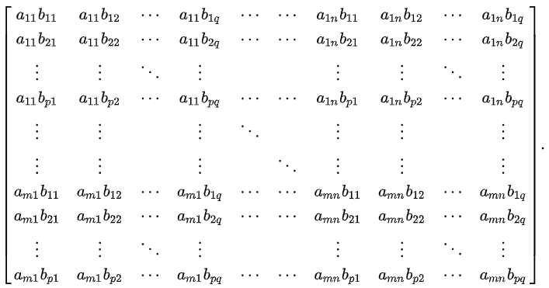)

Similarly,

$$\det\left(A\right)$$

= $$sigma\left({\left(−1\right)}^{i}\left(a_{1,i}\right)\det\left(A_{\left\{1,i\right\}}\right)\right)$$

where

$$R$$ is the set of indices that indicates rows that are removed .

$$W$$ is the set of indices that indicates columns that are removed.

Similarly,

$$\det\left(B\right)$$

= $$sigma\left({\left(−1\right)}^{i}\left(b_{1,i}\right)\det\left(B_{\left\{1,i\right\}}\right)\right)$$

where

$$R$$ Refers the set of indices that indicates rows that are removed.

$$W$$ Refers the set of indices that indicates columns that are removed.

Inverse matrix

Suppose:

Matrix $$A$$ has $$n$$ rows $$n$$ columns.

Matrix $$B$$ has $$m$$ rows $$m$$ columns.

Consider

*( )

= $$\left(A^{−1}A\right)$$ $$\left(B^{−1}B\right)$$

(by mixed-product property)

= $$I$$ $$I$$

= $$I$$

(However, the size will be $$n⋅m$$ row $$n⋅m$$ columns)

On the other hand,

* () = $$I$$

There are unique inverse matrix.

Thus,



Moore-Penrose psuedoinverse matrix

Do similar thing above.

Associativity with Hadmard product of matrices



= $$\left[a_{r,w}B\right]$$



= $$\left[c_{r,w}D\right]$$

Then



= $$\left[a_{r,w}B⋅c_{r,w}D\right]$$

On the other hand,



= $$\left[a_{r,w}c_{r,w}\right]$$

Then



= $$\left[a_{r,w}c_{r,w}Hadmard\left(B,D\right)\right]$$

Since $$Hadmard\left(B,D\right)$$ is element-wise mulitiplication for matrices and scalar from a number to matrix (or from a matrix to a number) has communicativity,

one can write it as

$$\left[a_{r,w}c_{r,w}Hadmard\left(B,D\right)\right]$$

= $$\left[a_{r,w}B⋅c_{r,w}D\right]$$

which completes proof.

Ref

[Kronecker product - Wikipedia](https://en.wikipedia.org/wiki/Kronecker_product)